

**INFORMATION MANAGEMENT FOR ENGINEERING**

**CSU44D01-202223**

**PROJECT ASTERIX – A Video Game Distribution System**

Name: Mudit Garg

TCD ID: 21355125

E-Mail ID: gargmu@tcd.ie

Mobile: +353892050748

In submitting this work, I verify that this submission is my very own work and I accept all obligation for any copyright infringement which can arise as a result of this submission.

**INTRODUCTION**

The application chosen for the purpose of representing information in the form of an ER model is of a video game distribution platform with similarities taken from real world examples like **Steam** by Value, **Origin** by Electronic Arts or **Epic Games**, etc.

During the COVID period, when the whole world was confined to their homes, the gaming industry saw a huge boom. With the huge catalogue of a variety of games and the inaccessibility of physical shops, the importance of maintaining and providing a digital forefront for the distribution of games started to gain traction.

This following report contains most of the details for how I would go about implementing such a digital platform’s database to manage the huge amount of data that accompanies with a popular video game distribution platform such as data about its *Users,* the hosted *Games,* the various *Genres* the hosted games are in, the *Languages* the platform supports, the various *Offers* the website currently holds for its users and the various *News* related to the various Publishers and the Games on its platform.

**ENTITIES AND THEIR ATTRIBUTES**

* *Users* – This table contains the list of all the users and their details, that are currently registered with the platform.

**Columns:** User_ID (Primary Key), First Name, Last Name, Email, Password, Language

**Table Creation:**

CREATE TABLE `users` (

  `User_ID` int NOT NULL AUTO_INCREMENT,

  `First Name` varchar(30) NOT NULL,

  `Last Name` varchar(45) NOT NULL,

  `Email` varchar(20) NOT NULL,

  `Password` varchar(20) NOT NULL,

  `Language` varchar(10) NOT NULL DEFAULT 'English',

  PRIMARY KEY (`User_ID`),

  UNIQUE KEY `User_ID_UNIQUE` (`User_ID`),

  UNIQUE KEY `Email_UNIQUE` (`Email`)

) COMMENT='List of all the users and their details in the database'

**Table Population:**

INSERT INTO `server_database`.`users` (`User_ID`, `First Name`, `Last Name`, `Email`, `Password`, `Language`) VALUES ('1', 'Mudit', 'Garg', 'gargmu@tcd.ie', 'FunnyNinja23', 'English');

INSERT INTO `server_database`.`users` (`User_ID`, `First Name`, `Last Name`, `Email`, `Password`, `Language`) VALUES ('2', 'Rahul', 'Garg', 'gargr@tcd.ie', '3flex@', 'Hindi');

INSERT INTO `server_database`.`users` (`User_ID`, `First Name`, `Last Name`, `Email`, `Password`, `Language`) VALUES ('3', 'Yashraj', 'Saluja', 'yashraj@gmail.com', 'maakaladla134', 'Punjabi');

INSERT INTO `server_database`.`users` (`User_ID`, `First Name`, `Last Name`, `Email`, `Password`, `Language`) VALUES ('4', 'Angad', 'Singh Garcha', 'garchaa@outlook.com', 'ikyktk69', 'French');

INSERT INTO `server_database`.`users` (`User_ID`, `First Name`, `Last Name`, `Email`, `Password`, `Language`) VALUES ('5', 'Ritwik', 'Kumar', 'kumarritwik@aol.com', 'coolDude13', 'Tamil');

INSERT INTO `server_database`.`users` (`User_ID`, `First Name`, `Last Name`, `Email`, `Password`, `Language`) VALUES ('6', 'Ananya', 'Garg', 'papaKipari@yahoo.com', 'cakemurder01', 'Hindi');

INSERT INTO `server_database`.`users` (`User_ID`, `First Name`, `Last Name`, `Email`, `Password`, `Language`) VALUES ('7', 'Mathew', 'McHart', 'mathewmc@aol.com', 'asdfmovie%', 'English');

**Final Table:**

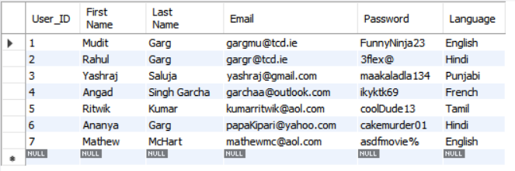

* *Games* – This table stores all the various games that are registered with the platform by the publishers for distribution among the users.

**Columns:** Game_ID (Primary Key), Name, Price, Release Date

**Table Creation:**

CREATE TABLE `games` (

`Game_ID` int NOT NULL AUTO_INCREMENT,

`Name` varchar(60) NOT NULL,

`Price` float NOT NULL DEFAULT '0',

`Release Date` datetime NOT NULL,

PRIMARY KEY (`Game_ID`),

UNIQUE KEY `Game_ID_UNIQUE` (`Game_ID`)

) COMMENT='List of all the games present in the database'

**Table Population:**

INSERT INTO `server_database`.`games` (`Game_ID`, `Name`, `Price`, `Release Date`) VALUES ('1', 'Uncharted', '23.99', '2015-10-21')

INSERT INTO `server_database`.`games` (`Game_ID`, `Name`, `Price`, `Release Date`) VALUES ('2', 'The Spiderman', '14.99', '2021-11-17')

INSERT INTO `server_database`.`games` (`Game_ID`, `Name`, `Price`, `Release Date`) VALUES ('3', 'GTA V', '8.99', '2013-09-10')

INSERT INTO `server_database`.`games` (`Game_ID`, `Name`, `Price`, `Release Date`) VALUES ('4', 'Red Dead Redemption', '18.99', '2018-06-16')

INSERT INTO `server_database`.`games` (`Game_ID`, `Name`, `Price`, `Release Date`) VALUES ('5', 'FIFA 19', '20.99', '2019-04-12')

INSERT INTO `server_database`.`games` (`Game_ID`, `Name`, `Price`, `Release Date`) VALUES ('6', 'Cyberpunk 2077', '15.99', '2020-11-30')

INSERT INTO `server_database`.`games` (`Game_ID`, `Name`, `Price`, `Release Date`) VALUES ('7', 'Spiderman: Miles Morales', '28.99', '2022-11-17')

INSERT INTO `server_database`.`games` (`Game_ID`, `Name`, `Price`, `Release Date`) VALUES ('8', 'Witcher 3', '32.99', '2018-03-25')

INSERT INTO `server_database`.`games` (`Game_ID`, `Name`, `Price`, `Release Date`) VALUES ('9', 'GTA: San Andreas', '0.00', '2009-08-14')

|  |  |
| --- | --- |
|  |  |

**Final Table:**

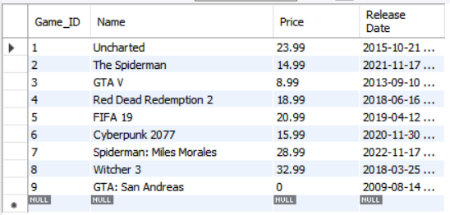

* *Library* – This entity is responsible for encapsulating all the games that every user has ever purchased on the platform.

**Columns:** Library Item ID (Primary Key), library_id (Foreign Key) (User ID from Users table), game_ids (Foreign Key) (Game ID from Games table)

**Table Creation:**

CREATE TABLE `user_libraries` (

`Library Item ID` int NOT NULL AUTO_INCREMENT,

`library_id` int NOT NULL,

`game_ids` int NOT NULL,

PRIMARY KEY (`Library Item ID`),

KEY `Library_ID_idx` (`library_id`),

KEY `Game_ID_idx` (`game_ids`),

CONSTRAINT `game_ids_library` FOREIGN KEY (`game_ids`) REFERENCES `games` (`Game_ID`),

CONSTRAINT `library_id` FOREIGN KEY (`library_id`) REFERENCES `users` (`User_ID`)

) COMMENT='Table that stores all the library items of all the users in the database by using the User_ID from the Users table and the Game_ID from the Games table'

**Table Population:**

INSERT INTO `server_database`.`user_libraries` (`Library Item ID`, `library_id`, `game_ids`) VALUES ('1', '1', '2')

INSERT INTO `server_database`.`user_libraries` (`Library Item ID`, `library_id`, `game_ids`) VALUES ('2', '1', '3')

INSERT INTO `server_database`.`user_libraries` (`Library Item ID`, `library_id`, `game_ids`) VALUES ('3', '1', '1')

INSERT INTO `server_database`.`user_libraries` (`Library Item ID`, `library_id`, `game_ids`) VALUES ('4', '4', '3')

INSERT INTO `server_database`.`user_libraries` (`Library Item ID`, `library_id`, `game_ids`) VALUES ('5', '2', '9')

INSERT INTO `server_database`.`user_libraries` (`Library Item ID`, `library_id`, `game_ids`) VALUES ('6', '7', '5')

INSERT INTO `server_database`.`user_libraries` (`Library Item ID`, `library_id`, `game_ids`) VALUES ('7', '7', '3')

INSERT INTO `server_database`.`user_libraries` (`Library Item ID`, `library_id`, `game_ids`) VALUES ('8', '7', '1')

INSERT INTO `server_database`.`user_libraries` (`Library Item ID`, `library_id`, `game_ids`) VALUES ('9', '7', '2')

INSERT INTO `server_database`.`user_libraries` (`Library Item ID`, `library_id`, `game_ids`) VALUES ('10', '7', '4')

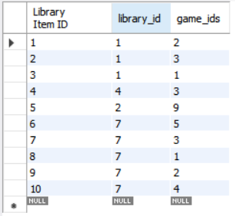**Final Table:**

* *Wishlist* – All the games that every user has added to their wish list is stored in this table.

**Columns:** Wishlist Item ID (Primary Key), wishlist_id (Foreign Key) (User ID from Users table), game_ids (Foreign Key) (Game ID from Games table)

**Table Creation:**

CREATE TABLE `user_wishlists` (

`Wishlist Item ID` int NOT NULL AUTO_INCREMENT,

`wishlist_id` int NOT NULL,

`game_ids` int NOT NULL,

PRIMARY KEY (`Wishlist Item ID`),

KEY `User_ID_idx` (`wishlist_id`),

KEY `Game_ID_idx` (`game_ids`),

CONSTRAINT `game_ids_wishlist` FOREIGN KEY (`game_ids`) REFERENCES `games` (`Game_ID`),

CONSTRAINT `Wishlist_ID` FOREIGN KEY (`wishlist_id`) REFERENCES `users` (`User_ID`)

) COMMENT='Table that stores all the wishlists of all the users in the database by using the User_ID from the Users table and the Game_ID from the Games table'

**Table Population:**

INSERT INTO `server_database`.`user_wishlists` (`Wishlist Item ID`, `wishlist_id`, `game_ids`) VALUES ('1', '1', '7')

INSERT INTO `server_database`.`user_wishlists` (`Wishlist Item ID`, `wishlist_id`, `game_ids`) VALUES ('2', '1', '6')

INSERT INTO `server_database`.`user_wishlists` (`Wishlist Item ID`, `wishlist_id`, `game_ids`) VALUES ('3', '2', '3')

INSERT INTO `server_database`.`user_wishlists` (`Wishlist Item ID`, `wishlist_id`, `game_ids`) VALUES ('4', '2', '8')

INSERT INTO `server_database`.`user_wishlists` (`Wishlist Item ID`, `wishlist_id`, `game_ids`) VALUES ('5', '6', '3')

INSERT INTO `server_database`.`user_wishlists` (`Wishlist Item ID`, `wishlist_id`, `game_ids`) VALUES ('6', '5', '5')

INSERT INTO `server_database`.`user_wishlists` (`Wishlist Item ID`, `wishlist_id`, `game_ids`) VALUES ('7', '4', '5')

INSERT INTO `server_database`.`user_wishlists` (`Wishlist Item ID`, `wishlist_id`, `game_ids`) VALUES ('8', '4', '8')

INSERT INTO `server_database`.`user_wishlists` (`Wishlist Item ID`, `wishlist_id`, `game_ids`) VALUES ('9', '3', '5')

INSERT INTO `server_database`.`user_wishlists` (`Wishlist Item ID`, `wishlist_id`, `game_ids`) VALUES ('10', '3', '2')

**Final Table:**

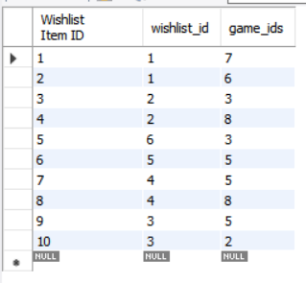

* *Cart* – Whenever a user decides to buy one or more games, he/she adds those games into their cart. This entity is the one which stores all the games of all the users which every user has added into their cart.

**Columns:** Cart Item ID (Primary Key), cart_id (Foreign Key) (User ID from Users table), game_ids (Foreign Key) (Game ID from Games table)

**Table Creation:**

CREATE TABLE `user_carts` (

`Cart Item ID` int NOT NULL AUTO_INCREMENT,

`cart_id` int NOT NULL,

`game_ids` int NOT NULL,

PRIMARY KEY (`Cart Item ID`),

KEY `User_ID_idx` (`cart_id`),

KEY `Game_ID_idx` (`game_ids`),

CONSTRAINT `cart_id` FOREIGN KEY (`cart_id`) REFERENCES `users` (`User_ID`),

CONSTRAINT `game_ids_cart` FOREIGN KEY (`game_ids`) REFERENCES `games` (`Game_ID`)

) COMMENT='Table that stores all the cart items of all the users in the database by using the User_ID from the Users table and the Game_ID from the Games table'

**Table Population:**

INSERT INTO `server_database`.`user_carts` (`Cart Item ID`, `cart_id`, `game_ids`) VALUES ('1', '1', '7')

INSERT INTO `server_database`.`user_carts` (`Cart Item ID`, `cart_id`, `game_ids`) VALUES ('2', '1', '6')

INSERT INTO `server_database`.`user_carts` (`Cart Item ID`, `cart_id`, `game_ids`) VALUES ('3', '7', '6')

INSERT INTO `server_database`.`user_carts` (`Cart Item ID`, `cart_id`, `game_ids`) VALUES ('4', '7', '7')

INSERT INTO `server_database`.`user_carts` (`Cart Item ID`, `cart_id`, `game_ids`) VALUES ('5', '3', '1')

INSERT INTO `server_database`.`user_carts` (`Cart Item ID`, `cart_id`, `game_ids`) VALUES ('6', '3', '2')

INSERT INTO `server_database`.`user_carts` (`Cart Item ID`, `cart_id`, `game_ids`) VALUES ('7', '3', '3')

INSERT INTO `server_database`.`user_carts` (`Cart Item ID`, `cart_id`, `game_ids`) VALUES ('8', '3', '5')

INSERT INTO `server_database`.`user_carts` (`Cart Item ID`, `cart_id`, `game_ids`) VALUES ('9', '3', '9')

INSERT INTO `server_database`.`user_carts` (`Cart Item ID`, `cart_id`, `game_ids`) VALUES ('10', '5', '9')

**Final Table:**

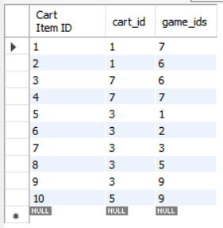

* *Platforms* – This platform also has the feature that enables the publishers to distribute their games to various platforms. Some of the examples that are considered here are PC (Windows, Mac, Linux, Chrome OS), Xbox and PlayStation. This table is the one which contains the various platforms on which every game is published and playable by the user.

**Columns:** Platform Item ID (Primary Key), Game_ID (Foreign Key) (Game ID from Games table), Platform ID, Platform Name

**Table Creation:**

CREATE TABLE `platforms` (

`Platform Item ID` int NOT NULL AUTO_INCREMENT,

`Game_ID` int NOT NULL,

`Platform_ID` int NOT NULL,

`Platform Name` varchar(45) NOT NULL,

PRIMARY KEY (`Platform Item ID`),

KEY `game_ids_platform_idx` (`Game_ID`),

CONSTRAINT `game_ids_platform` FOREIGN KEY (`Game_ID`) REFERENCES `games` (`Game_ID`)

) COMMENT='List of all the platforms that all the games in the database are released for'

**Table Population:**

INSERT INTO `server_database`.`platforms` (`Platform Item ID`, `Game_ID`, `Platform_ID`, `Platform Name`) VALUES ('1', '1', '1', 'PC')

INSERT INTO `server_database`.`platforms` (`Platform Item ID`, `Game_ID`, `Platform_ID`, `Platform Name`) VALUES ('2', '1', '2', 'Xbox')

INSERT INTO `server_database`.`platforms` (`Platform Item ID`, `Game_ID`, `Platform_ID`, `Platform Name`) VALUES ('3', '1', '3', 'Playstation')

INSERT INTO `server_database`.`platforms` (`Platform Item ID`, `Game_ID`, `Platform_ID`, `Platform Name`) VALUES ('4', '2', '1', 'PC')

INSERT INTO `server_database`.`platforms` (`Platform Item ID`, `Game_ID`, `Platform_ID`, `Platform Name`) VALUES ('5', '2', '2', 'Xbox')

INSERT INTO `server_database`.`platforms` (`Platform Item ID`, `Game_ID`, `Platform_ID`, `Platform Name`) VALUES ('6', '2', '3', 'Playstation')

INSERT INTO `server_database`.`platforms` (`Platform Item ID`, `Game_ID`, `Platform_ID`, `Platform Name`) VALUES ('7', '3', '1', 'PC')

INSERT INTO `server_database`.`platforms` (`Platform Item ID`, `Game_ID`, `Platform_ID`, `Platform Name`) VALUES ('8', '4', '2', 'Xbox')

INSERT INTO `server_database`.`platforms` (`Platform Item ID`, `Game_ID`, `Platform_ID`, `Platform Name`) VALUES ('9', '4', '3', 'Playstation')

INSERT INTO `server_database`.`platforms` (`Platform Item ID`, `Game_ID`, `Platform_ID`, `Platform Name`) VALUES ('10', '5', '1', 'PC')

INSERT INTO `server_database`.`platforms` (`Platform Item ID`, `Game_ID`, `Platform_ID`, `Platform Name`) VALUES ('11', '6', '1', 'PC')

INSERT INTO `server_database`.`platforms` (`Platform Item ID`, `Game_ID`, `Platform_ID`, `Platform Name`) VALUES ('12', '7', '1', 'PC')

INSERT INTO `server_database`.`platforms` (`Platform Item ID`, `Game_ID`, `Platform_ID`, `Platform Name`) VALUES ('13', '7', '3', 'Playstation')

INSERT INTO `server_database`.`platforms` (`Platform Item ID`, `Game_ID`, `Platform_ID`, `Platform Name`) VALUES ('14', '8', '1', 'PC')

INSERT INTO `server_database`.`platforms` (`Platform Item ID`, `Game_ID`, `Platform_ID`, `Platform Name`) VALUES ('15', '8', '2', 'Xbox')

INSERT INTO `server_database`.`platforms` (`Platform Item ID`, `Game_ID`, `Platform_ID`, `Platform Name`) VALUES ('16', '8', '3', 'Playstation')

INSERT INTO `server_database`.`platforms` (`Platform Item ID`, `Game_ID`, `Platform_ID`, `Platform Name`) VALUES ('17', '9', '1', 'PC')

INSERT INTO `server_database`.`platforms` (`Platform Item ID`, `Game_ID`, `Platform_ID`, `Platform Name`) VALUES ('18', '9', '2', 'Xbox')

INSERT INTO `server_database`.`platforms` (`Platform Item ID`, `Game_ID`, `Platform_ID`, `Platform Name`) VALUES ('19', '9', '3', 'Playstation')

INSERT INTO `server_database`.`platforms` (`Platform Item ID`, `Game_ID`, `Platform_ID`, `Platform Name`) VALUES ('20', '9', '4', 'Android')

**Final Table:**

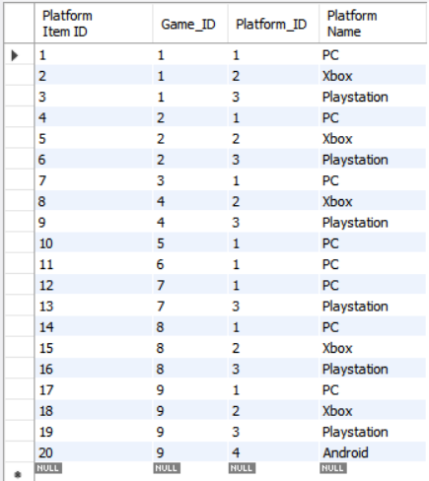

* *Publishers* – This table stores the names of the various publishers that have their games on the website.

**Columns:** Publisher Item ID (Primary Key), Publisher ID, Publisher Name, Game ID (Foreign Key)

**Table Creation:**

CREATE TABLE `publishers` (

`Publisher Item ID` int NOT NULL AUTO_INCREMENT,

`Publisher_ID` int NOT NULL,

`Publisher Name` varchar(60) NOT NULL,

`Game_ID` int NOT NULL,

PRIMARY KEY (`Publisher Item ID`),

KEY `game_id_publisher_idx` (`Game_ID`),

CONSTRAINT `game_id_publisher` FOREIGN KEY (`Game_ID`) REFERENCES `games` (`Game_ID`)

) COMMENT='Table that contains all the games that each of the games in the database belong to'

**Table Population:**

INSERT INTO `server_database`.`publishers` (`Publisher Item ID`, `Publisher_ID`, `Publisher Name`, `Game_ID`) VALUES ('1', '1', 'Sony Interactive Entertainment', '1')

INSERT INTO `server_database`.`publishers` (`Publisher Item ID`, `Publisher_ID`, `Publisher Name`, `Game_ID`) VALUES ('2', '1', 'Sony Interactive Entertainment', '2')

INSERT INTO `server_database`.`publishers` (`Publisher Item ID`, `Publisher_ID`, `Publisher Name`, `Game_ID`) VALUES ('3', '1', 'Sony Interactive Entertainment', '7')

INSERT INTO `server_database`.`publishers` (`Publisher Item ID`, `Publisher_ID`, `Publisher Name`, `Game_ID`) VALUES ('4', '2', 'Rockstar Games', '3')

INSERT INTO `server_database`.`publishers` (`Publisher Item ID`, `Publisher_ID`, `Publisher Name`, `Game_ID`) VALUES ('5', '2', 'Rockstar Games', '9')

INSERT INTO `server_database`.`publishers` (`Publisher Item ID`, `Publisher_ID`, `Publisher Name`, `Game_ID`) VALUES ('6', '2', 'Rockstar Games', '4')

INSERT INTO `server_database`.`publishers` (`Publisher Item ID`, `Publisher_ID`, `Publisher Name`, `Game_ID`) VALUES ('7', '3', 'Electronic Arts', '5')

INSERT INTO `server_database`.`publishers` (`Publisher Item ID`, `Publisher_ID`, `Publisher Name`, `Game_ID`) VALUES ('8', '4', 'CD Projekt Red', '6')

INSERT INTO `server_database`.`publishers` (`Publisher Item ID`, `Publisher_ID`, `Publisher Name`, `Game_ID`) VALUES ('9', '4', 'CD Projekt Red', '8')

**Final Table:**

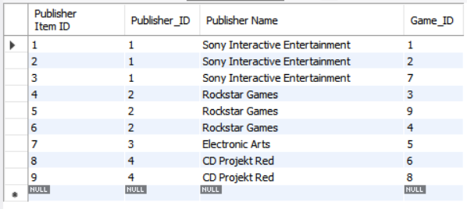

* *Genres* – Every game also has a detail about which genre the game belongs to. This table is responsible for storing that information

**Columns:** Genre Item ID (Primary Key), Genre ID, Genre Name, Game ID (Foreign Key)

**Table Creation:**

CREATE TABLE `genres` (

`Genre Item ID` int NOT NULL AUTO_INCREMENT,

`Genre_ID` int NOT NULL,

`Genre Name` varchar(45) NOT NULL,

`Game_ID` int NOT NULL,

PRIMARY KEY (`Genre Item ID`),

KEY `game_id_genre_idx` (`Game_ID`),

CONSTRAINT `game_id_genre` FOREIGN KEY (`Game_ID`) REFERENCES `games` (`Game_ID`)

) COMMENT='Table that contains all the genres that each of the games in the database belong to'

**Table Population:**

INSERT INTO `server_database`.`genres` (`Genre Item ID`, `Genre_ID`, `Genre Name`, `Game_ID`) VALUES ('1', '1', 'Action', '1')

INSERT INTO `server_database`.`genres` (`Genre Item ID`, `Genre_ID`, `Genre Name`, `Game_ID`) VALUES ('2', '2', 'Adventure', '1')

INSERT INTO `server_database`.`genres` (`Genre Item ID`, `Genre_ID`, `Genre Name`, `Game_ID`) VALUES ('3', '1', 'Action', '2')

INSERT INTO `server_database`.`genres` (`Genre Item ID`, `Genre_ID`, `Genre Name`, `Game_ID`) VALUES ('4', '2', 'Adventure', '2')

INSERT INTO `server_database`.`genres` (`Genre Item ID`, `Genre_ID`, `Genre Name`, `Game_ID`) VALUES ('5', '1', 'Action', '3')

INSERT INTO `server_database`.`genres` (`Genre Item ID`, `Genre_ID`, `Genre Name`, `Game_ID`) VALUES ('6', '2', 'Adventure', '3')

INSERT INTO `server_database`.`genres` (`Genre Item ID`, `Genre_ID`, `Genre Name`, `Game_ID`) VALUES ('7', '1', 'Action', '4')

INSERT INTO `server_database`.`genres` (`Genre Item ID`, `Genre_ID`, `Genre Name`, `Game_ID`) VALUES ('8', '2', 'Adventure', '4')

INSERT INTO `server_database`.`genres` (`Genre Item ID`, `Genre_ID`, `Genre Name`, `Game_ID`) VALUES ('9', '3', 'Unique', '4')

INSERT INTO `server_database`.`genres` (`Genre Item ID`, `Genre_ID`, `Genre Name`, `Game_ID`) VALUES ('10', '4', 'Sports', '5')

INSERT INTO `server_database`.`genres` (`Genre Item ID`, `Genre_ID`, `Genre Name`, `Game_ID`) VALUES ('11', '5', 'RPG', '6')

INSERT INTO `server_database`.`genres` (`Genre Item ID`, `Genre_ID`, `Genre Name`, `Game_ID`) VALUES ('12', '1', 'Action', '7')

INSERT INTO `server_database`.`genres` (`Genre Item ID`, `Genre_ID`, `Genre Name`, `Game_ID`) VALUES ('13', '2', 'Adventure', '7')

INSERT INTO `server_database`.`genres` (`Genre Item ID`, `Genre_ID`, `Genre Name`, `Game_ID`) VALUES ('14', '3', 'Unique', '8')

INSERT INTO `server_database`.`genres` (`Genre Item ID`, `Genre_ID`, `Genre Name`, `Game_ID`) VALUES ('15', '5', 'RPG', '8')

INSERT INTO `server_database`.`genres` (`Genre Item ID`, `Genre_ID`, `Genre Name`, `Game_ID`) VALUES ('16', '1', 'Action', '9')

INSERT INTO `server_database`.`genres` (`Genre Item ID`, `Genre_ID`, `Genre Name`, `Game_ID`) VALUES ('17', '2', 'Adventure', '9')

INSERT INTO `server_database`.`genres` (`Genre Item ID`, `Genre_ID`, `Genre Name`, `Game_ID`) VALUES ('18', '5', 'RPG', '9')

**Final Table:**

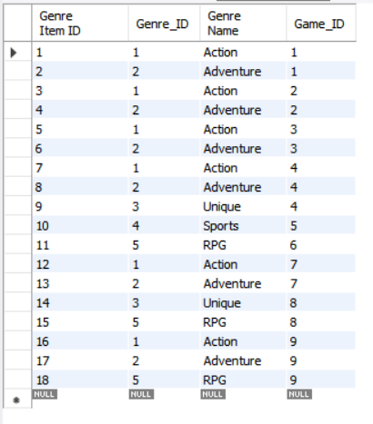

* *Friends* – Every user has the option to add other users to their friend list. This will enable them to play games together. Every user’s friend list is supposed to be stored in this table.

**Columns:** Game_ID (Primary Key), Name, Price, Release Date

**Table Creation:**

CREATE TABLE `friend_list` (

`Relationship ID` int NOT NULL AUTO_INCREMENT,

`user_id` int NOT NULL,

`friend_id` int NOT NULL,

PRIMARY KEY (`Relationship ID`),

KEY `user_ids_idx` (`user_id`),

KEY `friend_ids_idx` (`friend_id`),

CONSTRAINT `friend_ids` FOREIGN KEY (`friend_id`) REFERENCES `users` (`User_ID`),

CONSTRAINT `user_ids` FOREIGN KEY (`user_id`) REFERENCES `users` (`User_ID`)

) COMMENT='Table which contains the list of all the friends a user has using the User_ID from the Users table'

**Table Population:**

INSERT INTO `server_database`.`friend_list` (`Relationship ID`, `user_id`, `friend_id`) VALUES ('1', '1', '2')

INSERT INTO `server_database`.`friend_list` (`Relationship ID`, `user_id`, `friend_id`) VALUES ('2', '1', '3')

INSERT INTO `server_database`.`friend_list` (`Relationship ID`, `user_id`, `friend_id`) VALUES ('3', '1', '4')

INSERT INTO `server_database`.`friend_list` (`Relationship ID`, `user_id`, `friend_id`) VALUES ('4', '1', '5')

INSERT INTO `server_database`.`friend_list` (`Relationship ID`, `user_id`, `friend_id`) VALUES ('5', '2', '1')

INSERT INTO `server_database`.`friend_list` (`Relationship ID`, `user_id`, `friend_id`) VALUES ('6', '2', '3')

INSERT INTO `server_database`.`friend_list` (`Relationship ID`, `user_id`, `friend_id`) VALUES ('7', '2', '4')

INSERT INTO `server_database`.`friend_list` (`Relationship ID`, `user_id`, `friend_id`) VALUES ('8', '3', '1')

INSERT INTO `server_database`.`friend_list` (`Relationship ID`, `user_id`, `friend_id`) VALUES ('9', '3', '2')

INSERT INTO `server_database`.`friend_list` (`Relationship ID`, `user_id`, `friend_id`) VALUES ('10', '4', '1')

INSERT INTO `server_database`.`friend_list` (`Relationship ID`, `user_id`, `friend_id`) VALUES ('11', '4', '2')

INSERT INTO `server_database`.`friend_list` (`Relationship ID`, `user_id`, `friend_id`) VALUES ('12', '5', '1')

INSERT INTO `server_database`.`friend_list` (`Relationship ID`, `user_id`, `friend_id`) VALUES ('13', '5', '6')

INSERT INTO `server_database`.`friend_list` (`Relationship ID`, `user_id`, `friend_id`) VALUES ('14', '6', '5')

INSERT INTO `server_database`.`friend_list` (`Relationship ID`, `user_id`, `friend_id`) VALUES ('15', '4', '6')

INSERT INTO `server_database`.`friend_list` (`Relationship ID`, `user_id`, `friend_id`) VALUES ('16', '6', '4')

INSERT INTO `server_database`.`friend_list` (`Relationship ID`, `user_id`, `friend_id`) VALUES ('17', '6', '7')

INSERT INTO `server_database`.`friend_list` (`Relationship ID`, `user_id`, `friend_id`) VALUES ('18', '7', '6')

**Final Table:**

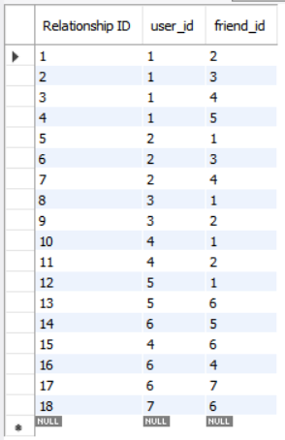

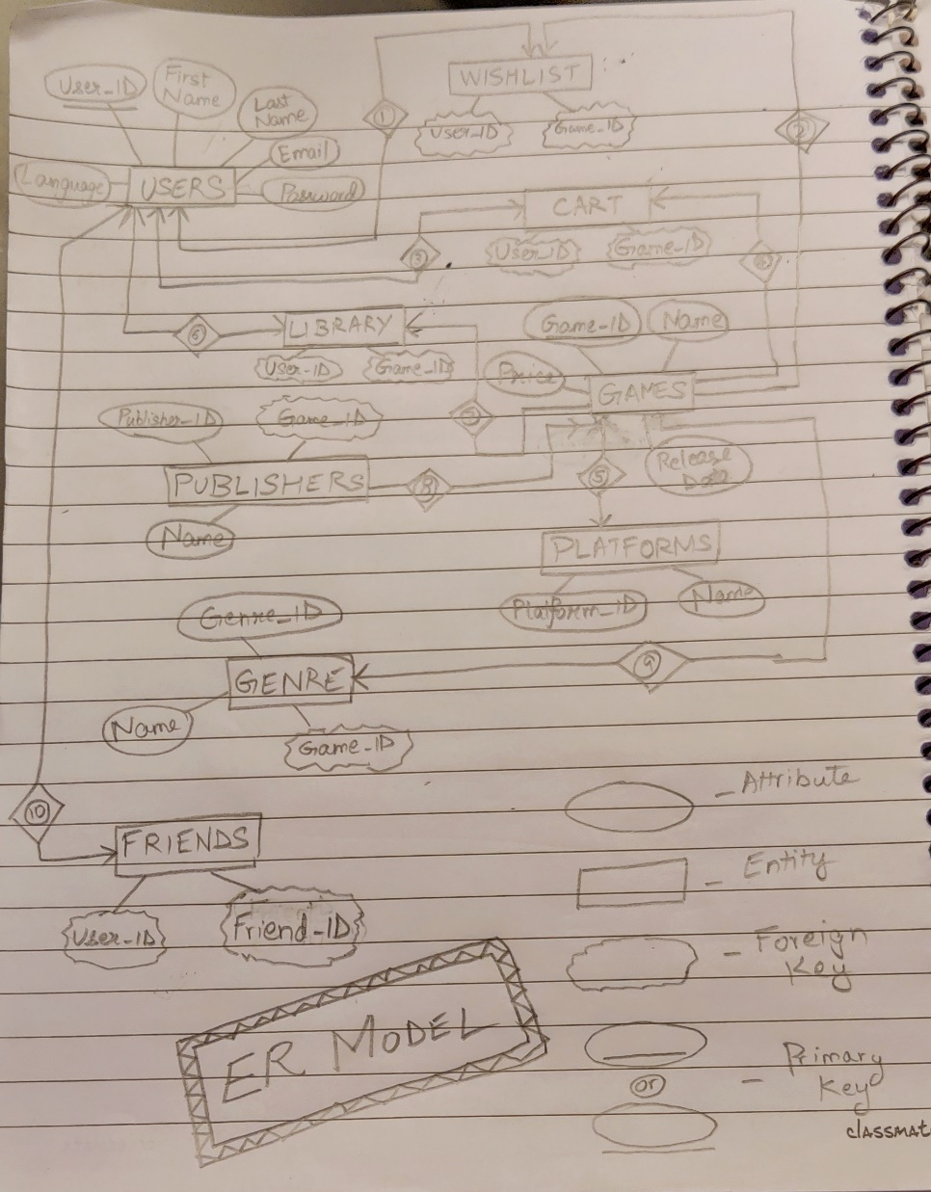**ENTITY RELATION MODEL**

**FUNCTIONAL DEPENDENCIES** (as generated by the SQL Workbench)

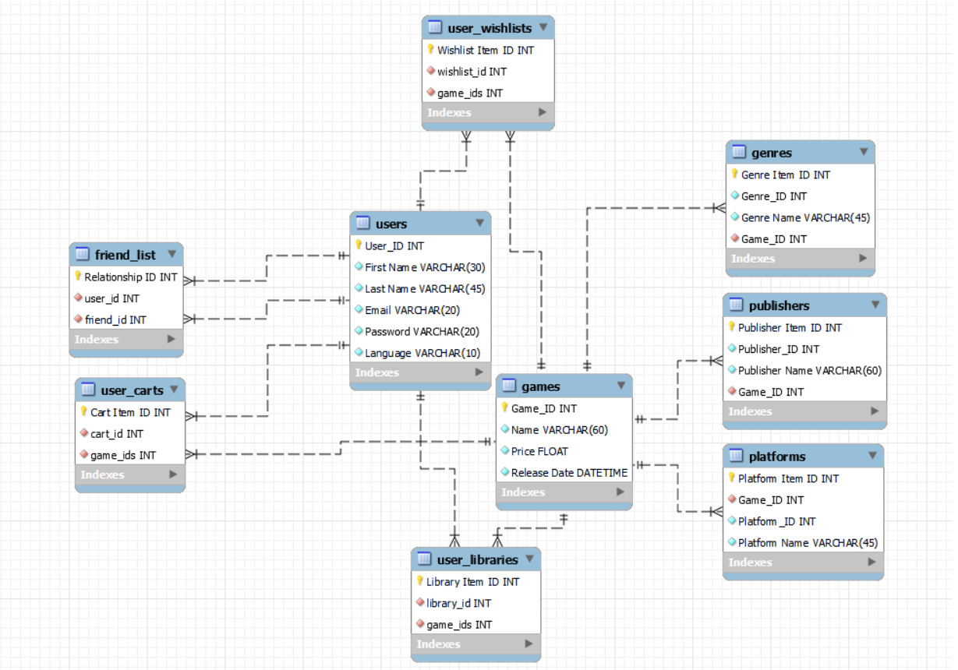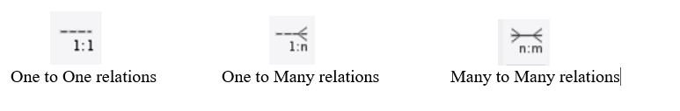

**TRIGGERS**

* *Check whether the cost of the game entered is mistakenly entered negative*

*Solution: Maybe the (-ve) sign was mistakenly entered. So, the cost is converted to its positive counterpart using ABS () function. This is done BEFORE INSERT ON way.*

**Code:**

DROP TRIGGER IF EXISTS `games`.`check_price`;

CREATE TRIGGER `check_price` BEFORE INSERT ON `games` FOR EACH ROW BEGIN

IF NEW.price < 0

THEN SET NEW.price = abs(NEW.price);

END IF;

END

**VIEWS**

* *Retrieving the User IDs of those users who have purchased GTA 5 (using Game ID = 3) and have it in their Library*

**Code:**

CREATE VIEW `gta5_holders` AS

SELECT

`user_libraries`.`library_id` AS `GTA 5 Holders' User ID`

FROM

`user_libraries`

WHERE

(`user_libraries`.`game_ids` = 3)

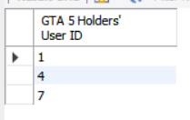**Output:**

* *Retrieving the Game IDs of those games whose genre is ‘Action’*

**Code:**

CREATE VIEW `action_games` AS

SELECT

`genres`.`Game_ID` AS `Action_Game_IDs`

FROM

`genres`

WHERE

(`genres`.`Genre Name` = 'Action')

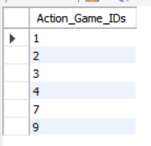**Output:**

**DATA AND SECURITY**

Data Integri